
___________________________________________________________________________________________

THE HANDS WERE GIVEN
Aces High 1 Jokers Wild

A Stunning new Queer Cyberpunk Epic
By O.E. Tearmann

Released and published by Amphibian Press!
The book is available worldwide in digital and print across all platforms!

Life's a bitch. She deals off the bottom of the deck. But you play the hands you're given

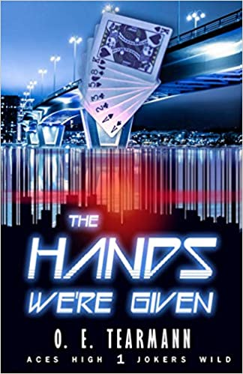
Aidan Headly never wanted to be the man giving orders. That's fine with the Democratic State Force base he's been assigned to command: they don't like to take orders. Nicknamed the Wildcards, they used to be the most effective base against the seven Corporations owning the former United States in a war that has lasted over half a century. Now the Wildcards are known for creative insubordination, chaos, and commanders begging to be reassigned. Aidan is their last chance. If he can pull off his assignment as Commander and yank his ragtag crew of dreamers and fighters together, maybe they can get back to doing what they came to do: fighting for a country worth living in.

Amazon.ca: The Hands We're Given: Tearmann, O. E.: 9781949693836: Books - Amazon.ca
Amazon.com: Amazon.com: The Hands We're Given: Aces High, Jokers Wild, Book 1 (Audible Audio Edition): O.E. Tearmann, Kirt Graves, Amphibian Press: Audible Audiobooks
Barnes and Noble: The Hands We're Given by O. E. Tearmann, Paperback | Barnes & Noble® (barnesandnoble.com)

PRAISE FOR THE HANDS WERE GIVEN:

“This is a lovely paean to the healing power of respectful personal connections among comrades, friends, and lovers.” – BookLife

""I'd recommend this to those who love futuristic dystopian stories where the oppressed fight back the best way they can, where love is discovered, where a family is rebuilt, and where something precious can be built in a desolate Country."
–MM Good Book Reviews

OTHER BOOKS IN THE SERIES:

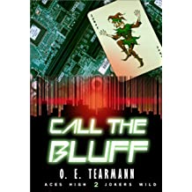 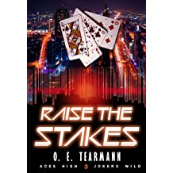 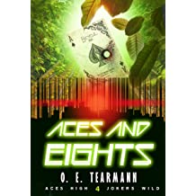Book 2: Call The Bluff Book 3: Raise The Stakes Book 4: Aces And Eights

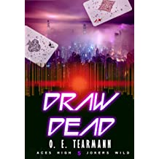

Book 5: Draw Dead
Release March 8

SHORT STORIES IN THE SERIES:

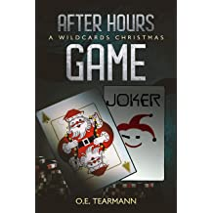
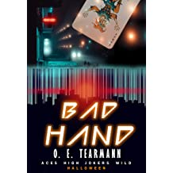

Book 2.5: After Hours Game Book 3.5: Bad Hand

ABOUT O.E. TEARMANN:



O.E. Tearmann is the author of the Aces High, Jokers Wild series. Their books include strong themes of diversity and found family, providing a surprisingly hopeful take on a dystopian future. Bringing their own experiences as a marginalized author together with flawed but genuine characters, Tearmann’s work has been described as “Firefly for the dystopian genre.” Publisher’s Weekly called it “a lovely paean to the healing power of respectful personal connections among comrades, friends, and lovers.”
Tearmann lives in Colorado with two cats, their partner, and the belief that individuals can make humanity better through small actions. They are a member of Rocky Mountain Fiction Writers and the Queer Scifi group. In their spare time, they teach workshops about writing GLTBQ characters, speak and plant gardens to encourage sustainable agricultural practices, and play too many video games.

To request additional review copies or an interview with O.E. Tearmann, please contact Mickey Mikkelson at Creative Edge Publicity: mickey.creativeedge@gmail.com / 403.464.6925.

We look forward to the coverage!

